7.40: First find the acceleration:
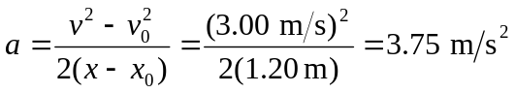
Then, choosing motion in the direction of the more massive block as positive:
